What it means to sponsor a
Child at St. Anthony’s and
Nabbingo

Uganda is a poor and predominantly rural African country where many families do not have the financial means to send their children to school.

Fr. Lawrence Kimbowa, a Ugandan priest who was born in Nabbingo and stationed at St. Anthony’s Parish in Migyera, Uganda, first came to St. Peter’s for Mission Sunday in 2007.
As a child, Fr. Lawrence was sponsored by an American family, and was the first in his family to graduate from secondary school.

Fr. Lawrence believes that the best gift he could give to others in Uganda is to look for educational sponsors for children. “Illiteracy is the #1 problem facing these families--a lifetime problem that compounds all other problems (e.g. employment, health needs, etc). These children want to go to school but their families cannot afford the costs.” Some teenagers are in primary grades because they did not have the opportunity for school in their younger years.

What does sponsorship cover?

Your $360/year donation for primary education benefits the entire community:
- A child is granted admission to school.

- A school uniform, textbooks, malaria mosquito net, & school supplies are provided to the sponsored child. A noon meal is provided for the child and other children in the community awaiting sponsors.

- School land is cultivated to increase the food supply for the students and the community.

- Older children are allowed to finish any primary education not yet completed so they can enter age-appropriate secondary grade levels and then professional or university training.

Please note: Annual educational costs for non-primary students are:

- $660 for secondary
- $800 for seminary
- $1200 for university
How can I help?

Sponsor a child’s education through:

- One calendar year payment of $360 (for primary grades).

- Or, if you wish to sponsor a secondary student, seminarian or university student please increase your payment to cover this and indicate this on the attached form.

Checks can be made payable to
the Church of St. Peter, with
“Uganda Sponsorship” in the
memo line.

100% of your donation is tax deductible and is wholly used
In Uganda for the children of
St. Anthony’s and Nabbingo.

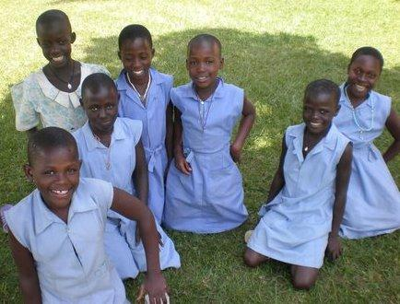

Detach and mail with payment to:
Church of St. Peter/Uganda Sponsorship
1405 Hwy 13 P.O. Box 50679
Mendota, MN 55150

YES, I/we want to make a donation of:

_____ $360/year (Primary student level)
_____ $660/year (Secondary student level)
_____ $800/year (Seminarian level)
_____ $1200/year (University student level)

____ Enclosed is my check for $_____
for one year of sponsorship.

____ Enclosed is my check for $_____
for partial payment. Please bill me for the remaining amount.

____ We would like to make a one-time donation of $______ to help in any way we can.

Name ____________________________
Date of donation____________________
Address___________________________
___________________________
Phone: ___________________________

Please designate one of the following:
We would like to:
______ have a specific student assigned to us

______ support any student with the most need

Printing of this brochure is made possible by the
generous donation of Jim & Donna Oricchio.

For more information on the
Uganda Mission Project please contact:
Ralph Dumond at ashjonmike@comcast.net
or Jim Hoey at ajehoey@comcast.net
or at the Church of St. Peter, PO Box 50679, Mendota, MN 55150

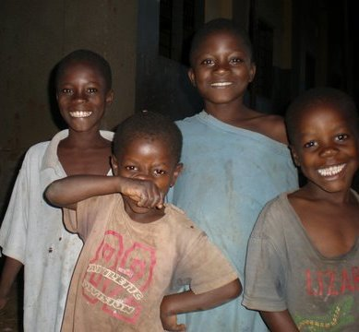

Can You
Help Us
Go To
School?

